Syndemic: A Graphical Representation
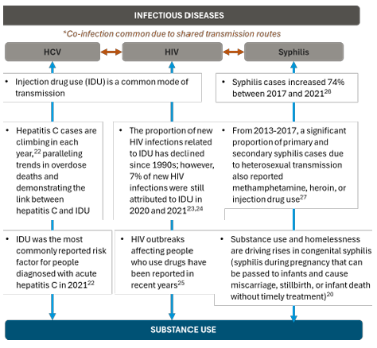
SOURCE: Opioid Response Network. (2024). Your Guide to Integrating Infectious Disease Testing and Treatment Services in Opioid Treatment Programs. Providence, RI: Author.
Link to Toolkit: https://attcnetwork.org/wp-content/uploads/2024/08/FINAL-Integrating-Infectious-Disease-Services-into-OTPs-Guide-08.16.24.pdf.

Hepatitis C Point of Care Test and Treat Algorithm
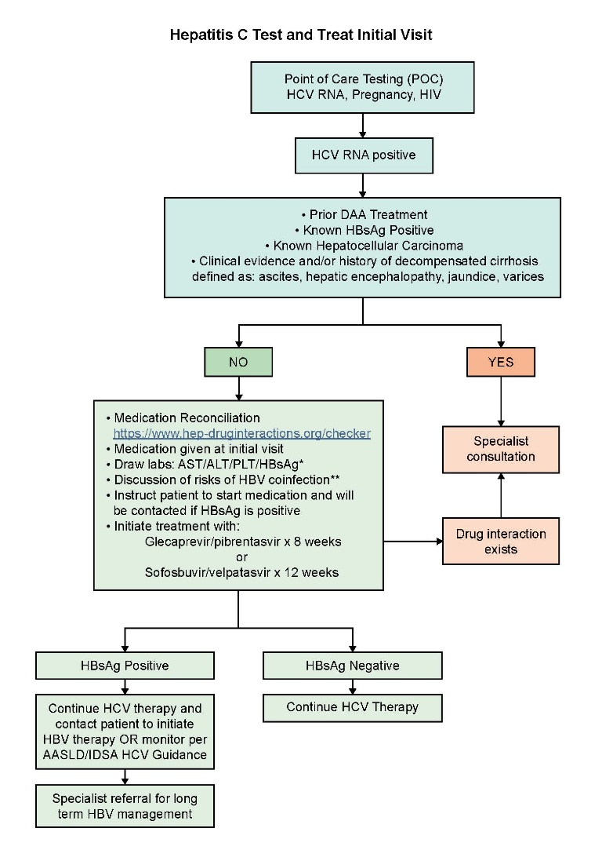
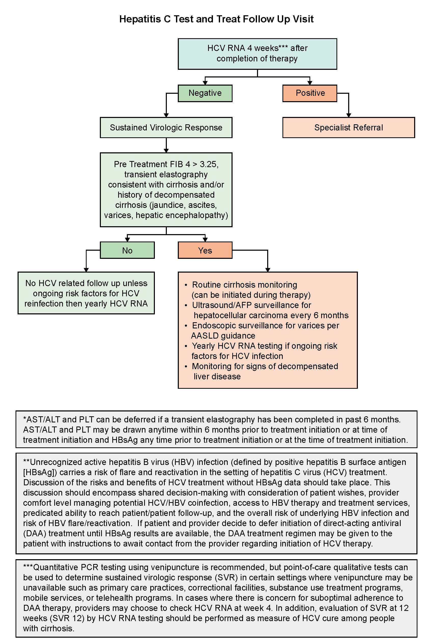
Checklist for Implementing Integrated Services
